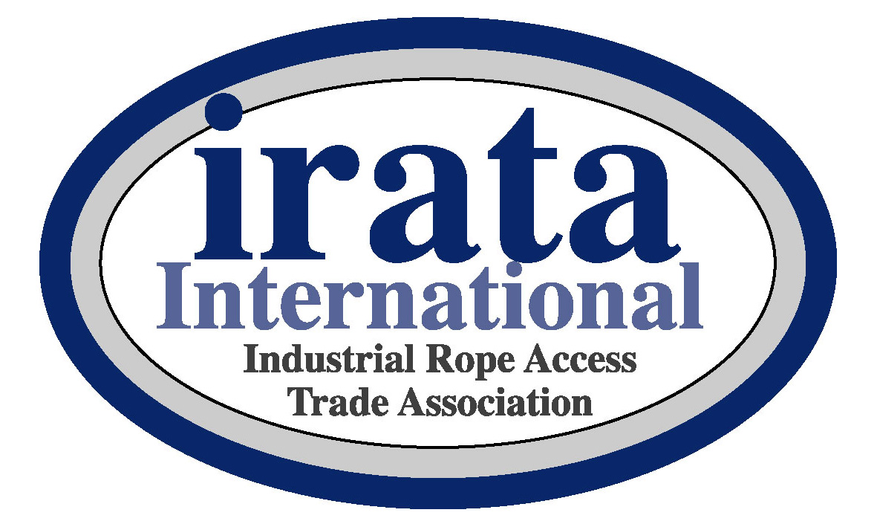

PRE-TRAINING COURSE CHECKLIST –

INTERNAL AUDIT
This Pre-Training Course Checklist (IRATA International form 006 version 2014-Aug-01) is to assist IRATA International Training Member Companies (TMCs) in the preparation and provision of training courses and in complying with the annual audit requirements.

The TMC shall complete a venue specific Risk Assessment (Job Safety Analysis) for each facility used for training courses. They shall ensure the suitability of the facility, equipment and that training personnel are competent. All trainers must be fully briefed and provided with TMC training procedures, inspection records, equipment user information and other required documents detailed in this checklist prior to training.

Additionally, the TMC shall carry out a pre-training course internal audit, and complete a copy of this form 006 for each venue that they use. No training shall be undertaken until the TMC venue specific Risk Assessment and this form 006 have both been completed and displayed at the venue. The name and IRATA number of all Lead and Assistant Trainers shall be completed on this form.

Each time that there is a change to facilities, equipment, training procedure or personnel, this form must be reviewed to ensure compliance.
Each Lead Trainer should assist the TMC in the completion of this form for each venue in which they train and ensure that all Assistant Trainers have knowledge of both the Risk Assessment and the form 006 requirements.

The venue specific Risk Assessment and the completed 006 form should be made available to IRATA Assessors on request. If they are not available or completed correctly or the Lead Trainer is not as named, the Assessor will decline to continue with the assessment until they have been completed satisfactorily.

If a Trainer/Assessor has any compliance concerns they will not undertake any training/assessments until these concerns have been raised and both venue specific Risk Assessment and the 006 form have been reviewed and actioned appropriately. If an Assessor is not satisfied with a training facility and they refuse to carry out the assessment, they shall complete a copy of this form 006 detailing the non-acceptable requirements and submit this to IRATA for the attention of both the Audit and Training Chairpersons.

Copies of all completed 006 shall be retained for audit purposes.
This form does not replace a venue specific Risk Assessment.

IRATA International Training Member Company: |  |  | Lead Trainer:
 |  |  | IRATA number:
Venue: |  |  | Assistant Trainer:
 |  |  | IRATA number:
Audit Item | References:  ICOP = international  code of practice  TACS = Training, assessment and certification scheme  BL = By-laws | Item to be checked/be available.  Guidance in italics. |  | Acceptable | Not Acceptable | A reason must be given for all not acceptable boxes
1 | ICOP 1.4.3.5  TACS 4.4.2, 7.7.4  BL 4.1.5 | IRATA certificate for all Rope Access training personnel are in date with expiry date noted.  Copies of certificates to be available. | Expiry
2 | ICOP 1.4.3.8, 2.5.2.1 (c) & 2.5.3.2.4 (n)  TACS 7.7.5,  BL 4.1.4 | Appropriate First Aid for Lead Trainer are kept up to date.  Copies of certificates to be available. | Expiry
3 | ICOP 2.2.2 (c)  Annex N.1 (a) & (b) TACS 7.7.3 | Insurance in date and specifies Rope Access training.  Expiry date: ……………..
4 | ICOP 2.2.2 (d)  & 2.2.4.5  TACS 7.7.13 | Specific Risk Assessment is made for each training venue with appropriate control measures detailed and implemented.  Venue specific Risk Assessment along with the assessment of foreseeable misuse of equipment shall to be available.
5 | TACS 7.7.12 & 7.7.20 | Trainers have access to the Web based IRATA Trainer File and Safety bulletins, ICOP, TACS & updates. Safety bulletins should also be available as teaching aids.  ICOP & TACS shall be provided to trainees in appropriate language.  (Either Paper or electronic copies.)
6 | ICOP 2.2.2 (d, f & m), 2.2.5 & 2.2.6  TACS 7.7.19 | Training procedures for management of training is available on-site  E.g. the trainer’s responsibilities, maintenance of procedures, facilities & equipment, records of any structure testing, equipment inspection and delivery of training, trainee inductions, rescue plans, training records etc.
7 | ICOP 2.5.3.2.3 & 2.2.6  TACS 7.7.18 | Procedure to be in place to ensure that all sub-contract trainers are adequately briefed on TMC training procedures prior to course commencement. Relevant at new venues or at venues where trainer has not previously worked or where significant changes have occurred.

8 | TACS 7.7.21 | Sufficient equipment is available and is safe to use.  Level 2 & 3 training requires additional equipment for rigging exercises.
9 | ICOP 2.10.7  TACS 7.7.23 | Equipment is stored correctly and securely.  Designated storage area that is; clean, dry, cool, dark and secure from unauthorised interference or contamination.
10 | ICOP 2.8  ICOP Annex H  TACS 4.4.5, 7.7.20, 7.7.24 | Rope Access and lifting equipment is sufficiently marked to allow traceability to inspection records. Includes sub-contractors’ equipment. Copies of instructions and certificates to be available.
11 | ICOP 2.7.1.7, 2.9.1 (g) & 2.10.1.1  TACS 7.7.20 (e) | Manufacturers’ equipment user instructions for all items of equipment are available for use during training. Includes sub-contractors’ equipment. Copies of instructions and certificates to be available.
12 | ICOP 2.8, Annex N & Annex I  TACS 7.7.22 | Records of equipment inspection are in date including, load rating, lifespan etc. Declarations of conformity are kept if applicable.  Including sub-contractors equipment.
13 | ICOP 2.2.6(i) &  2.11.11 TACS 7.7.6 | Appropriate First Aid equipment is available.  Regulation First Aid Kits etc. specific to region.
14 | TACS 7.7.7 | Facilities for classroom theory and examination shall be available
15 | ICOP 2.11.10  TACS 7.7.8 | Normal welfare facilities are available.
16 | TACS 7.7.9, 7.7.10, 7.7.11, 7.7.30 | Training venue is suitable; adequate lighting levels, protected from adverse weather, isolated from other conflicting activities and free from excessive noise level or other sources of distraction or disturbance.  An area to ascend or descend in free hanging space is recommended to be at least 7m, but shall not be less than a working height of 6m. NOTE: a” working height means an area which is accessible for training.  An area to ascend / descend against a flat wall / surface of at least 6m.
17 | ICOP Annex B.2.1 (f) | Access to telephone for contacting emergency services.  Telephone number should be noted on this form. |  |  | Number………….….
18 | ICOP 1.4.1.1 (f ii & iv),  1.4.2.6 & 2.11.8  TACS 7.7.11, 7.7.27 | Measures to protect third parties are adequate. Safety signage & barriers are present with clear demarcation of the training area to exclude unauthorised persons. Relates to exclusion zones, helmet wearing, use of lanyards to prevent falling objects, empty pockets etc.
19 | ICOP 2.11.8.3 | Anchor areas are protected from unauthorised access.
20 | ICOP 2.7.9, 2.11.2  Annex F  TACS 7.7.25/26 | Anchors shall meet minimum static strength requirement. Eye-bolt anchors, scaffolds, ladders and structures are inspected.  Records available.
21 | TACS 7.7.28 | Training structures used to support persons display signage indicating their loading capacity & loading direction  Number of persons per beam or platform, direction of loading on structures etc.
22 | TACS 7.7.29, 7.7.30, 7.7.31 | Locations to train: ascent, descent, passing and rigging small and large re-belays and performing rope-to-rope transfers rigged at least 3.5 m above the ground.
23 | TACS 6.4.8.1 & 7.7.31 | Locations requiring deviations to redirect ropes for both protection and positioning purposes rigged at least 3.5 m above the ground.  Deviate to avoid danger and to aid work positioning.
24 | ICOP 2.7.10 & 2.11.3  TACS 6.6.14, 7.7.31 | A location to ascend and descend past mid-rope obstructions using suitable rope protection devices.  Should deal with protection for each rope.
25 | TACS 7.7.32 | Training area has platforms where the ropes pass through 90° between the anchors and ground. This shall also be used to demonstrate the use of suitable rope protection measures.
26 | TACS 6.7.2.2.1 (b), 6.7.2, 7.7.33 | A structure that provides anchorages for aid climbing at least 5 m horizontal using moveable anchors. To include sections where the trainee is fully and/or partially supported by the structure and where foot loops are required.
27 | TACS 6.7.2.2.1 (a), 6.7.3 & 7.7.33 | An area that allows aid climbing in suspension using work-positioning lanyards attached to fix and mobile anchors is required.  These exercises, which shall include the use of foot loops shall be performed over a distance of at least 5 m (horizontal) and 3 m (vertical). Obstructions shall be in place (e.g. joints/junctions in steel) so that the trainee has to remove their mobile anchors.
28 | ICOP Annex E  TACS 7.7.34 | A structure of at least 5 m high to allow climbing using Y-shaped fall arrest lanyards (Twin-tailed energy-absorbing fall arrest lanyards).
29 | ICOP 2.11.1.2  TACS 7.7.35 | The working ropes and back-up ropes have their own separate anchors. Both anchors may be connected to each other for added security.
30 | TACS 7.7.37 | Suitable anchors to allow horizontal, diagonal and three-dimensional exercises for level 3 rigging and rescue.  Consideration to loading directions and increased loadings.
31 | ICOP 2.2.4.4, 2.7.11 & Annex G  TACS 6.2.9.2.2, 7.7.14, 7.7.17 | If a live ‘casualty’ is used for rescue training, the controls are included in the Risk Assessment.  A seat is recommended for all live casualties.
32 | ICOP Annex A  TACS 7.7.15 & 7.7.16 | Dummies /masses of at least 70 kg are available for hauling and rescue exercises. Manual handling precautions shall apply.
33 | ICOP 1.4.3.11, 2.2.2(e), 2.2.5.3, 2.2.6(h & i),  ICOP Annex B.2.2 (t),  Annex G.2.2, G.2.8,  TACS 7.7.17 | Rescue plans with appropriate rescue equipment are available.  Detailed in method statements, training procedures or venue specific instructions. Rescue method for the generic situations should be identified.  Equipment and techniques used for two person loads is to be detailed in training procedure.

